Project virtualization

**Implementation Plan**

Author : Arnoud Smit, Iva Kapel, Sander van der Himst, Jandrik Blom & Thom Mekelenkamp

Version : 1.1

Date : 19 September ‘14

Inhoudsopgave

Outcomes And Endgoals 3

Core Goals: 3

Outcomes: 3

MoSCoW 4

Project organisation 5

Roles and responsibilities 6

Roles 6

Implementation scenario 7

Costs 8

Man-hours: 8

Sales 8

Return on investment 9

Break even 9

Pay-off time 9

Implementation schedule 10

Fallback scenario 11

# Outcomes And Endgoals

We aim to deliver a product that has a solid working core which lets the user and admins oversee and control the main functions of the web application. We also tend to filter a lot of unnecessary extra functions so we can keep our interface clean and simple for our users. With this in mind the goals in this project gave us a better view and we have set a few checkpoints that certainly have to be met.

## Core Goals:

* There has to be website where new customers can register and order their products.
* The system needs a database that stores the customer information.
* The customers must be able to configure and order a virtual machine with an OS, RAM and storage of their own choice.
* Customers need to be able to manage their VM/Products and get an overview of their account.

Our Experience in this project has led to several discoveries about the way the rollout of the project went.

## Outcomes:

* For the rollout of the project we saw that the individual segments of can be made isolated from one another. The only thing we had to keep in mind was that these segments eventually needed to be connected with ‘linkable’ code (for example. Database connection)

# MoSCoW

Must haves:

The final product must contain the following parts in order to operate:

* There has to be new website where new customers can register and order their products.
* The system needs a database that stores the customer information.
* The customers must be able to configure and order a virtual machine with an OS, RAM and storage of their own choice.
* There has to be a new ordering system that gets an update as soon as a customer orders a system.
* The order that a customer placed has to be processed by the ordering system.
* After ordering, the customer must get a notification on email that its virtual machine is ready for use. That same email also has to contain the customer’s log in data for the machine.

Should haves:

* There should be functioning security on the website to protect the customer details and log in data.
* The customers should be able to update their personal information on the website.
* The website should be available on every platform such as PC, tablet and smartphone
* There should be a security system on the virtual machines to protect customers from unauthorised actions by strangers.

Could haves:

Won’t, would haves:

* The customers would be able to choose from more OS types.
* The customers would be able to link multiple virtual machines to each other.
* The customers would be able to upgrade the hardware that they configured on the machine in order to get more performance when they need it.

# Project organisation

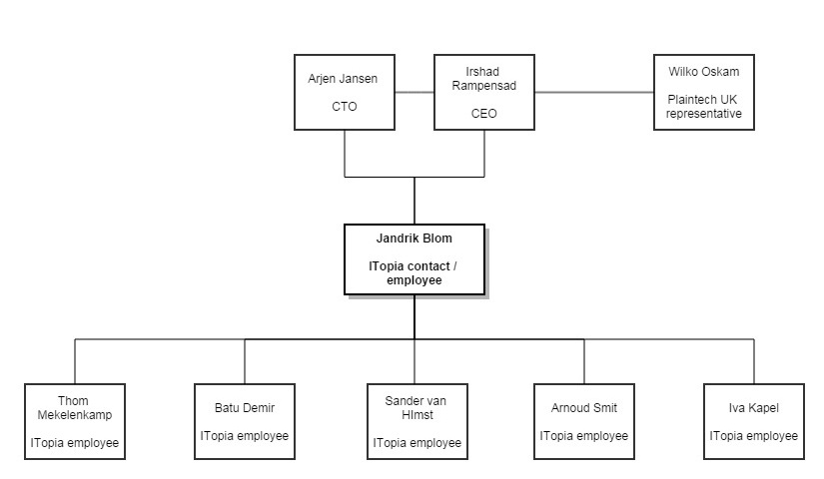

# Roles and responsibilities

The matrix shows the dividing of roles in our team

|  |  |  |  |  |  |  |
| --- | --- | --- | --- | --- | --- | --- |
| Name | Contact | Java | Networking | secretary | HTML / CSS | Python |
| Jandrik | V | V | V |  | V | V |
| Batu |  | V | V |  | V | V |
| Iva |  | V | V |  | V | V |
| Sander |  | V | V |  | V | V |
| Arnoud |  | V | V | V | V | V |
| Thom |  | V | V | V | V | V |

# Roles

Contact:

This is the first person on the team to communicate with the Plaintech representatives. And he will form the main connection for the team to Plaintech.

Java:

All the team members listed in ‘Java’ are working on the Java-script on the website, and the Java programming for additional software that might be required for the project

Networking:

The team members listed for ‘networking’ will work on the connection between the server, the client, the website and the database. And make sure that the servers are configured correctly.

Secretary:

The secretaries are the team members that take notes on every important moment(team and Plaintech meetings) during two weeks. After the period of two weeks the secretary job circulates to other team members.

HTML / CSS:

All the team members that are listed on ‘HTML / CSS’ are building the website that will make customers able to order and access their products.

Python:

The team members listed in ‘Python’ are creating software that is required for the system.

# Implementation scenario

This scenario represents a possibility of an implementation of this project.

We will be starting with placing 3 server racks which will approximately 120 blades. To give the users a pleasant experience with the servers, we set a limit of 20 VMs per blade. These racks will be enough to handle 2400 VMs without any complications. Each of these servers will have the same image with the configuration settings so that every server can create its own environment with virtual machines.

After the images are deployed on the server we will implement the webserver on which the website will run. This webserver is connected to all other servers within the datacentre so all the servers will run as one.

Whenever the average amount of VMs per server blade gets near 20 we will start implementing a new server rack.

We have a general calculation to calculate the amount of server racks that will be required.



# Costs

* Server : €6153,- * 2000 = €12.306.000,-
* Server software : €1555,-
* Windows server 2012 : Deal with Microsoft ®: annually €150.000

to get as many licenses we need

* Datacenter : 2000 / 40 = 50 Racks * €500,- per month

= €25.000,- per month.

## Man-hours:

1 hour = €45,- Estimated hours needed: 1800

260 hrs: Building the website

200 hrs: Installing the server

740 hrs: Implementation and connecting of the website and server

200 hrs: Documentation

480 hrs: Security

*note* Per month

120 hrs: Maintainability--------------

260 * 45= € 11.700,-

300 * 45= € 13.500,-

740 * 45= € 33.300,-

200 * 45= € 9000,-

480 * 45= € 21.600,-

*note* Per month

120 * 45= € 5400,- ----------------

Total €95.400,-

**Total costs = € 12.426.400,-**

# Sales

Service levels:

* Low : € 20,- Server rent = € 15,- /month
* Medium : € 40,-
* High : € 60,- Service costs are monthly payments

Monthly costs for the client (includes server rent):

* Low : € 35,-

*note* for the ROI calculation we assume at least 50.000 contracts annually with a medium service level

* Medium : € 55,-
* High : € 75,-

50.000 * 12 months = 600.000 annual payments

600.000 * € 55,- = € 33.000.000,- each year

# Return on investment

Estimated sales: € 33.000.000,-

Estimated costs: € 12.426.400,-

€ 33.000.000,- / € 12.426.400,- * 100 = 266

## Break even

€ 12.426.400,- / € 55,- = ~225.934 monthly payments to break even on the investment of the project

## Pay-off time

€ 33.000.000,- / 12 months = € 2.750.000,- each month

|  |  |  |  |  |  |  |  |  |  |
| --- | --- | --- | --- | --- | --- | --- | --- | --- | --- |
| Jan | Feb | Mar | Apr | May | Jun | Jul | Aug | Sep | oct |
| 2.75 | 5.5 | 11 | 22 | 44 | 88 |  |  |  |  |

*All the numbers listed in this table are millions.

The pay-off time for the project is approximately 4 months

# Implementation schedule

# Fallback scenario

Whit in our fallback scenario we are considering de following things:

* Which SLA did the customer purchase.
* Did they choose the option for a back-up.

If a customer purchases a new virtual machine he or she will be given the option to include a back-up solution. In case of a fallback scenario the data of all the customers will be safely stored in one of our protected data locations. The servers can be restored with the images stored in our back-up center.

In our back-up solution we’ve decided to back-up all the data from all our customers. This choice was made deliberately due to several things:

* Excellent customer service.
* Customers will tell other people of our customer service.

In case the data of a customer is lost and they didn’t have one of our premium solutions with back-up. The customer can buy there lost data. The downside for the customer will be that the lost data will cost them significant more than when they choose for the premium SLA.